## Sleepy Joe’s Wimpy Tail Wags The Dog Of War, Part 1

## Sleepy Joe’s Wimpy Tail Wags The Dog Of War, Part 2

From: <https://www.davidstockmanscontracorner.com/sleepy-joes-wimpy-tail-wags-the-dog-of-war-part-2/?mc_cid=4ce73de859&mc_eid=23bf5d4e64>

As to the Ukrainian border hysteria, ……… here is 800 years of history and if you can find a “border” worth defending with American blood and treasure, please be our quest. It all started around 1000 AD with the arrival of **the “Rus”** — the people whose name got tacked on to Russia. They were originally Viking traders and settlers who made their way from the Baltic Sea through the marshes and forests of Eastern Europe down toward the fertile river-lands of what’s now Ukraine.

The first major center of the “Rus” was at Kiev, established in the 9th century. In 988, Vladimir, a prince of the Kievan Rus, was baptized by a Byzantine priest in the old Greek colony of Khersonesos on the Crimean coast. His conversion marked the advent of Orthodox Christianity among the Rus and remains a moment of great nationalist symbolism for Russians.  In fact, Putin invoked the original “Vladimir” in a speech when justifying his annexation of Crimea in 2014.

In any event, successive Mongol invasions beginning in the 13th century subdued Kiev’s influence, and led eventually to the movement of most of the “Rus” settlements to the north, including Moscow.

In their place, the Turkic descendants of the Mongol Golden Horde formed their own Khanate along the northern rim of the Black Sea in what is designated in the map below as the “Crimean Khanate”. And as we explained in Part 1, that became the Turkish territory that Catherine the Great purchased in 1783 as part of the Czarist quest for a warm water port to base its Black Sea Fleet.

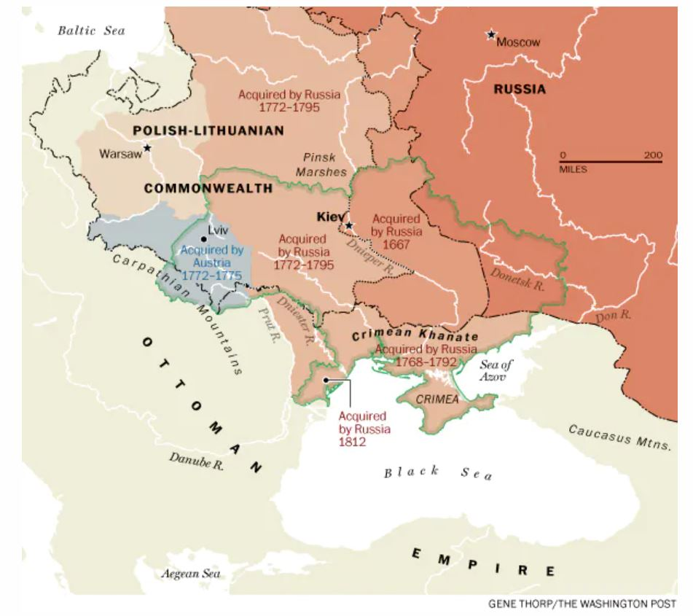

Prior to this re-russification of the Crimea, of course, the surrounding lands now called Ukraine lay on the margins of competing empires. It was a region of permanent contest and shifting borders. The Polish-Lithuanian Commonwealth—which, at its peak, encompassed a huge swath of Europe — had dominated much of the land. But the Ukraine would also see the incursions of Hungarians, Ottomans, Swedes, bands of Cossacks and the armies of successive Russian czars.

As these meandering borders appeared and disappeared repeatedly through the 17th century, Russia and Poland  eventually split much of the territory of what’s now Ukraine along the Dnieper river, as shown above. In 1667, the areas to the east, which now include the Donbas, were acquired by Russia and incorporated into the Russian State.

Then, the aforementioned Russia’s advance continued during the subsequent century during the rule of Catherine the Great. Not surprisingly, she imagined her domains along the Black Sea constituted “Novorossiya or “new Russia” As also shown in the map above, these Ukrainian lands to the west of the Dnieper were acquired by Moscow between 1772 and 1795.

*“Believe me, you will acquire immortal fame such as no other sovereign of Russia ever had,” said Grigoriy Potemkin, a prominent adviser to Catherine the Great, when offering the empress*[*counsel in 1780*](http://www.newrepublic.com/article/121222/one-year-after-russias-annexation-world-has-forgotten-crimea)*on plans to wrest Crimea away from Ottoman suzerainty. “This glory will open the way to still further and greater glory.”*

Meanwhile, the partitions of Poland in the late 18th century (1795) led to the far western city of [Lviv](https://en.wikipedia.org/wiki/Lviv)—once a major regional hub and a center of Jewish culture in Eastern Europe —being transferred from Russian sovereignty to the Austro-Hungarian empire. It was there in the mid-19th century where [Ukrainian nationalism](http://en.wikisource.org/wiki/Catholic_Encyclopedia_(1913)/Ruthenians) began to take hold, rooted in the traditions and dialects of the region’s peasants and the aspirations of intellectuals who had fled the stifling rule of Russia further to the east.

***Alas, as the 19th century drew to a close, there really was no sovereign state of Ukraine.*** The lands had been divided between the Russian Empire to the east and the Austro-Hungarian Empire to the west. Had America’s ruling class back then wished to police the borders of the world, which they surely didn’t, there would have been no Ukrainian borders to police!

So the mystery question recurs. Who created the modern borders and state of Ukraine, then?

Why, holy moly, it was the commies themselves!

Simply take a gander at the map below. Both the Russian Empire and Austro-Hungarian empires collapsed in the bloody trenches of the Great War, and subsequently disappeared from the pages of history. But their bloody successors in Moscow busied themselves in a multi-step evolution that resulted in what today passes for Ukraine.

First, near the end of World War I, the new Bolshevik government was desperate to end hostilities with Germany and its allies and signed a treaty in the town of Brest-Litovsk in 1918 ceding some of Russia’s domains west of the Dnieper to the Central powers and recognizing the independence of others.

Of course, the terms of this desperate 11th hour treaty were nullified by Germany’s defeat later in the year, but the genie of Ukrainian nationalism was out of the bottle. Independence movements of various stripes sprung up in cities like Lviv, Kiev and Kharkiv, but were eventually all swept away amid the wider struggle for power in Russia.

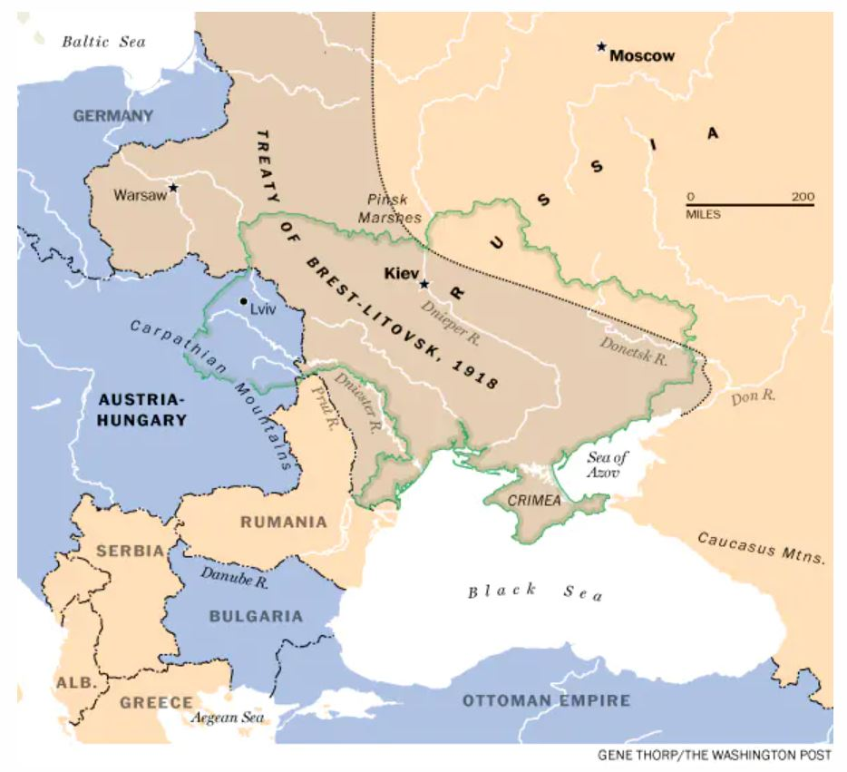

So at the end of World War I, a revived Poland reclaimed Lviv and a chunk of what’s now western Ukraine. The country was one of the key battlegrounds of the Russian Civil War, pitting Bolshevik forces against an array of armies, led by loyalists to the old czarist regime as well as other political opportunists. After a lot of bloodshed — and other battles with Poland — the Bolsheviks emerged triumphant and **officially declared the Ukrainian Socialist Soviet Republic in 1922.**

That’s represented by the purple area of the map below, to which were later added gifts from Stalin’s Red Army (blue area, 1939-1945) and the previously mentioned gift of Crimea (red area) by Khrushchev in 1954.

In short, America’s borders were established by democratic politicians and had stood the test of 167 years of time.

By contrast, today’s Ukraine depicted below is the hand-work of tyrants and commies, which changed by the decade.

And Washington now apparently chooses the latter. That’s insane and in Part 3 we will further amplify the reasons why.

[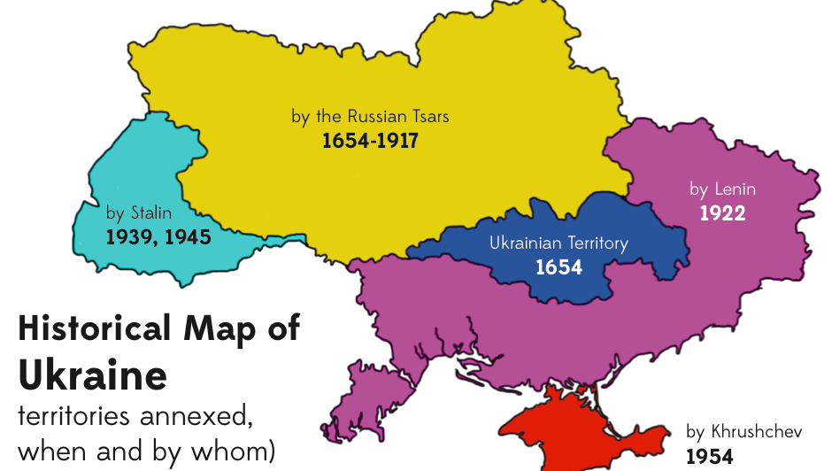](https://www.google.com/url?sa=i&rct=j&q=&esrc=s&source=images&cd=&ved=&url=https://www.globalresearch.ca/who-are-the-ukrainians/5627413&psig=AOvVaw2sa816lKbP_qnSqcUb--s4&ust=1574444831948132)

See [Ukrainian language](https://en.wikipedia.org/wiki/Ukrainian_language#Differences_between_Ukrainian_and_other_Slavic_languages) .